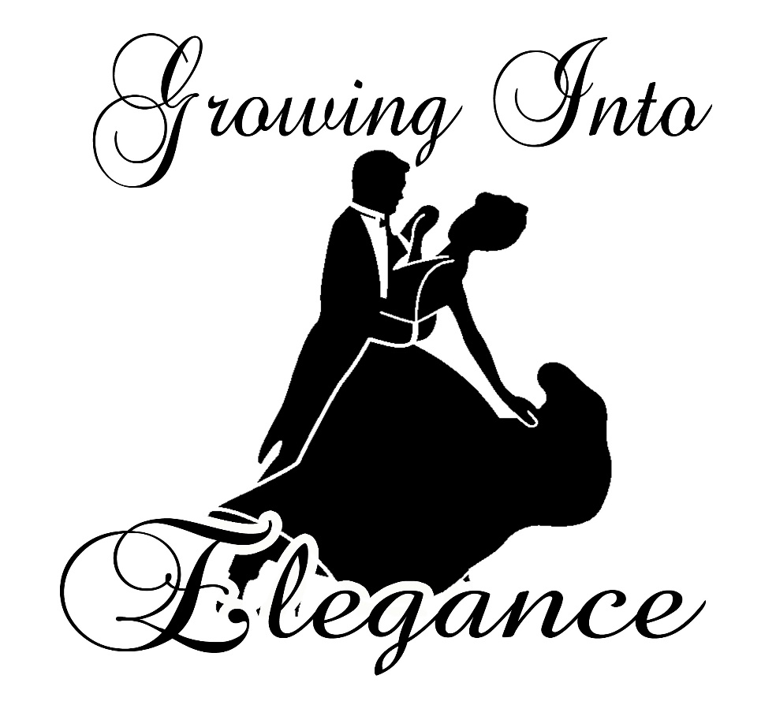

Growing Into Elegance Foundation is a debutante/beautillion program designed to prepare young girls and boys early as age 3 to the high school graduates. Our certified academic support, etiquette training, awareness, and community services. As they advance in skills, knowledge, and gracefully grow in age, we strive to build character, reinforce moral values, and increase self-esteem. The older youth, usually high school juniors and seniors, transition from young girls and boys to young ladies and gentlemen. We help empower them to understand their inner and outer beauty while enhancing their social refinement with continuous sessions. Becoming a young lady or gentleman should be a celebrated milestone in the lives of every young person. The final stage of preparation is the introduction of the debs/beaus into society at a Grand Finale Ball. We are dedicated in embracing inclusiveness and diversity. We welcome you to be a part of this memorable experience of a lifetime. Please contact one of the instructors listed below or visit our website at [www.growingintoelegance.com](http://www.growingintoelegance.com) for additional information.

***PLEASE CALL FOR ADDITIONAL INFORMATION***

Colette White Pate 504-609-9755